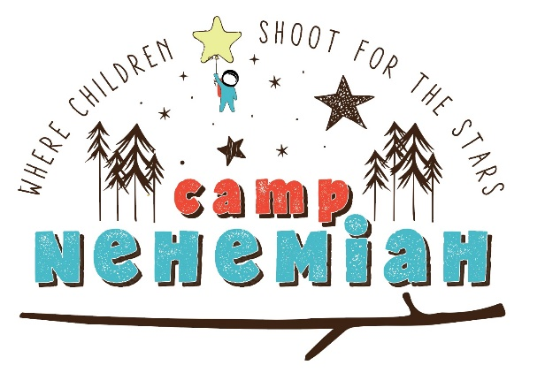
March 11, 2021 · Live From Hotel ZaZa to Your Living Room

Name: ________________________________________________________________________
(Please print name as it should appear in printed materials.)

Contact Person (if different): _______________________________________________________

Email:_________________________________________________________________________

- YES, I/WE WOULD LIKE TO STAND UP FOR CHILDREN BY SPONSORING CAMP NEHEMIAH AT THE FOLLOWING LEVEL:

- $20,000 – Presenting Trailhead Sponsor*
  - Presenting rights for event
  - Pre-recoded advertising opportunity
  - Exclusive opportunity to provide your name/logo on a promotional item in the camper box
  - 20 PREMIUM camper boxes we distribute to your guests
- $10,000 – Stargazer Sponsor*
  - 10 PREMIUM camper boxes we distribute to your guests
- $5,000 – Campfire Sponsor*
  - 10 Camper boxes you distribute to your guests
- $2,500 – S’mores Sponsor*
  - 5 Camper boxes you distribute to your guests
- $250 – Household Camper Experience
  - Receive a camper box

*All sponsors receive live on camera recognition and your name/company on printed invitations, social media and all event materials.

- We cannot participate in the above-mentioned ways, but we would like to support Nehemiah Center with a tax-deductible contribution of $__________________.

- My check is enclosed Please invoice me Please charge my credit card

Card #____________________________________________ Exp. Date___________________

Signature______________________________________________________________________

Please email or mail this response to Nehemiah Center by
January 22, 2021 to be included in print materials.
Attention: Christina Luna, Development Director, CLuna@NehemiahCenterHouston.org

